  What the USFS Restructuring Means for National Parks and Forests | Abstract  Significant 2025 and 2026 restructuring under the Trump administration and the Department of Government Efficiency (DOGE) has led to deep cuts in the U.S. Forest Service (USFS). These changes include a 65-67% proposed budget reduction and a "sweeping restructuring" aimed at decentralizing the agency.  Kevin Murphy

Table of Contents
Top 5 Major Cuts and Policy Changes 2
Impact on Services 2
Most Vocal Advocacy Groups 3
Primary Methods of Opposition 3
Political Opposition 4
Most Impacted National Parks (2025–2026) 4
Common Service Disruptions 5
The "Interagency" Crisis 5
Key Government Leaders 6
Key Senate Leaders 6
Key House Leaders 6
Major Legislative and Formal Actions (April 2026) 7
The Response from Alaska 8
Alaska’s Delegation Responses 8
Local Impact on Alaska 9
State-Level Pushback 9
Impact on Tourism Numbers 10
Social Media Sentiment 10
Top 5 Social Media Groups & Campaigns 11
Washington-based research facilities slated for closure 11
Washington Research Facilities Slated for Closure 11
Facilities Remaining Open 12
USFS Reorganization Context 12
What This Means — And Why It Matters Now 12

Top 5 Major Cuts and Policy Changes
Mass Staffing Reductions: The agency lost nearly 8,900 employees (over 25% of its workforce) between 2024 and early 2026. This includes the loss of roughly 1,400 wildfire-certified personnel.
Abolishing Regional Offices: All nine regional offices, which previously managed 154 national forests, are being eliminated. They are being replaced by a state-based model with 15 state directors reporting to political appointees.
Research Facility Shuttering: The administration is closing 57 of 77 research facilities (approximately 75%). This impacts critical long-term studies on wildfire science, drought, and forest resilience.
Headquarters Relocation: The national headquarters is being moved from Washington, D.C., to Salt Lake City, Utah. Critics argue this move is designed to force senior staff into "relocation-based" resignations.
Elimination of Grant Programs: The budget proposes to entirely cut State, Private, and Tribal Forestry grants. These funds previously supported local wildfire mitigation and non-federal land management.

Impact on Services
The workforce and funding reductions have already resulted in measurable service declines as of April 2026:
- Service Category - Recorded Impact (2025-2026)
- Wildfire Mitigation - Activity declined by 38% compared to previous averages.
- Trail Maintenance - Declined by 22%, reaching a 15-year low.
- Overall Budget - 2026 request sought a $6 billion cut (67% reduction).
- Timber Production - Mandated to increase by 250 million board feet annually

Most Vocal Advocacy Groups
Opposition to the restructuring of the U.S. Forest Service (USFS) is being led by a diverse coalition of federal unions, environmental nonprofits, outdoor recreation companies, and political leaders. These groups are using a combination of lawsuits, public awareness campaigns, and congressional pressure to challenge the administration's 2025–2026 mandates.
National Federation of Federal Employees (NFFE): As the primary union for USFS workers, NFFE is arguably the most vocal opponent. They have filed lawsuits and are actively lobbying Congress to block what they call a "reckless dismantlement" of the agency.
The "SaveUSFS.org" Coalition: Launched by the advocacy group Our Parks (also known as altNPS), this campaign has mobilized over 70 outdoor brands to oppose the restructuring. Notable member companies include:
Patagonia: One of the first major brands to issue a scathing formal statement.
REI Co-op, The North Face, and Columbia Sportswear: These companies argue that the cuts threaten the $23 billion economic output generated by forest recreation.
Environmental Nonprofits: Major organizations like the Sierra Club, Center for Biological Diversity, and NRDC are leading legal challenges. They specifically target rules that fast-track industrial projects by stripping away public comment requirements.
Forest Service Employees for Environmental Ethics (FSEEE): This watchdog group, composed of current and former USFS staff, has been vocal about the "talent drain" and the potential for federal land to be ceded to state or private control.
Primary Methods of Opposition
Legal Action: Lawsuits challenging the legality of mass layoffs and the relocation of offices without congressional approval.
Legislative Pressure: A coalition of 80 members of Congress sent a formal letter to the administration urging a reversal of the firing of 3,400 fire-qualified personnel.
Public Campaigns: Digital awareness via SaveUSFS.org and social media efforts to pressure outdoor brands to take a public stand.
Tribal Advocacy: Tribal representatives have filed formal complaints regarding the loss of "irreplaceable knowledge" about treaty rights and forest conditions.

Political Opposition
Democratic lawmakers, particularly those on the House Agriculture Subcommittee on Forestry, have framed the cuts as a national security risk that leaves communities vulnerable to catastrophic wildfires. They are currently working to include funding protections in the 2026 Fiscal Year budget to prevent the use of federal money for office relocations.

Most Impacted National Parks (2025–2026)
While the U.S. Forest Service (USFS) and National Park Service (NPS) are separate agencies, the 2025–2026 restructuring and deep budget cuts (nearly $4 billion combined) have heavily impacted iconic national parks. These parks rely on shared interagency resources—particularly for firefighting, trail maintenance, and law enforcement—that have been severely depleted.
Grand Canyon (AZ): Faced deep staff cuts leading to long entrance lines, reduced campground maintenance, and the suspension of zoonotic disease monitoring (e.g., plague and rabies).
Yosemite (CA): Experienced the loss of essential skilled staff (including its only locksmith), leading to the closure of five campgrounds and the Pioneer History Center due to insufficient security.
Zion (UT): Reported a 25% staffing reduction, causing a 10% decrease in its Search and Rescue (SAR) team and hindering water quality testing and emergency response.
Joshua Tree (CA): Suffered from unstaffed campgrounds and reduced "preventative search and rescue," which resulted in a wildfire starting near a vacant ranger station.
Glacier (MT): Now relies on an "honor system" with QR codes for fee collection due to lack of booth staff, losing critical safety interactions between rangers and visitors.
Acadia (ME): Forced to cancel youth education and conservation programs because there was no staff available to manage them.

Common Service Disruptions
Emergency Response, Voyageurs, Mesa Verde, and Assateague Island reported delays or cuts to emergency and lifeguard services.
Education & Tours, Carlsbad Caverns and Lincoln Birthplace canceled all guided ranger tours.
Facilities, Gettysburg fired reservation staff, leading to indefinite cancellations of visitor cabin bookings.
Maintenance, Mount Rainier and Rocky Mountain report "unsustainable" trail and facility conditions.

The "Interagency" Crisis
Many of these parks share a "checkerboard" border with National Forests. The USFS loss of 1,400 wildfire-certified staff directly endangers adjacent National Parks. For instance, the Appalachian Trail, which crosses both jurisdictions, has seen major delays in hurricane damage repairs because there is no coordinated workforce to clear the path for 2026 hikers.


Key Government Leaders
Democratic lawmakers are leading the opposition through committee hearings, legislative moratoriums, and formal letters to the administration. The charge is primarily organized by ranking members of the committees with direct oversight of the U.S. Department of Agriculture (USDA) and the Department of the Interior.

Key Senate Leaders
Senator Amy Klobuchar (D-MN): As the Ranking Member of the Senate Agriculture Committee, she organized a coalition of 32 senators in April 2026 to formally oppose the USFS reorganization.
Senator Martin Heinrich (D-NM): The Ranking Member of the Senate Energy and Natural Resources Committee, Heinrich has introduced legislation to block mass firings at both the Forest Service and the Department of the Interior.
Senator Jeff Merkley (D-OR): Ranking Member of the Senate Appropriations Subcommittee, Merkley has aggressively questioned administration officials about the loss of wildfire-certified personnel.
Senator Patty Murray (D-WA): Has targeted the 38% cut to park facility operations, labeling the budget a "recipe for disaster" for federal maintenance and road crews.

Key House Leaders
Representative Jared Huffman (D-CA): The Ranking Member of the House Natural Resources Committee, Huffman is a primary voice against the "dismantlement" of public lands. He recently led 80 members in a letter demanding the reversal of 3,400 layoffs.
Representative Chellie Pingree (D-ME): Top Democrat on the House Appropriations Subcommittee on Interior and Environment. She has been vocal about states being unable to absorb the costs of federal service withdrawals.
Representative Sanford Bishop (D-GA): Ranking Member of the House Appropriations Agriculture Subcommittee. He has grilled USDA leadership on how $4.9 billion in cuts will impact rural community services.
Representative Andrea Salinas (D-OR): Ranking Member of the House Agriculture Subcommittee on Forestry. She co-authored bills to impose an immediate moratorium on agency firings.

Major Legislative and Formal Actions (April 2026)
Anti-Firing Legislation - Bills introduced by Salinas and Heinrich aim to establish a moratorium on all firings while Congress investigates the restructuring.
Appropriations "Blockers" - Some lawmakers are attempting to use the 2026/2027 budget bills to explicitly prohibit federal funds from being used to move headquarters or close regional offices.
GAO Investigations - Many of these leaders have requested the Government Accountability Office (GAO) to audit previous relocation efforts to prove they result in a loss of scientific expertise.
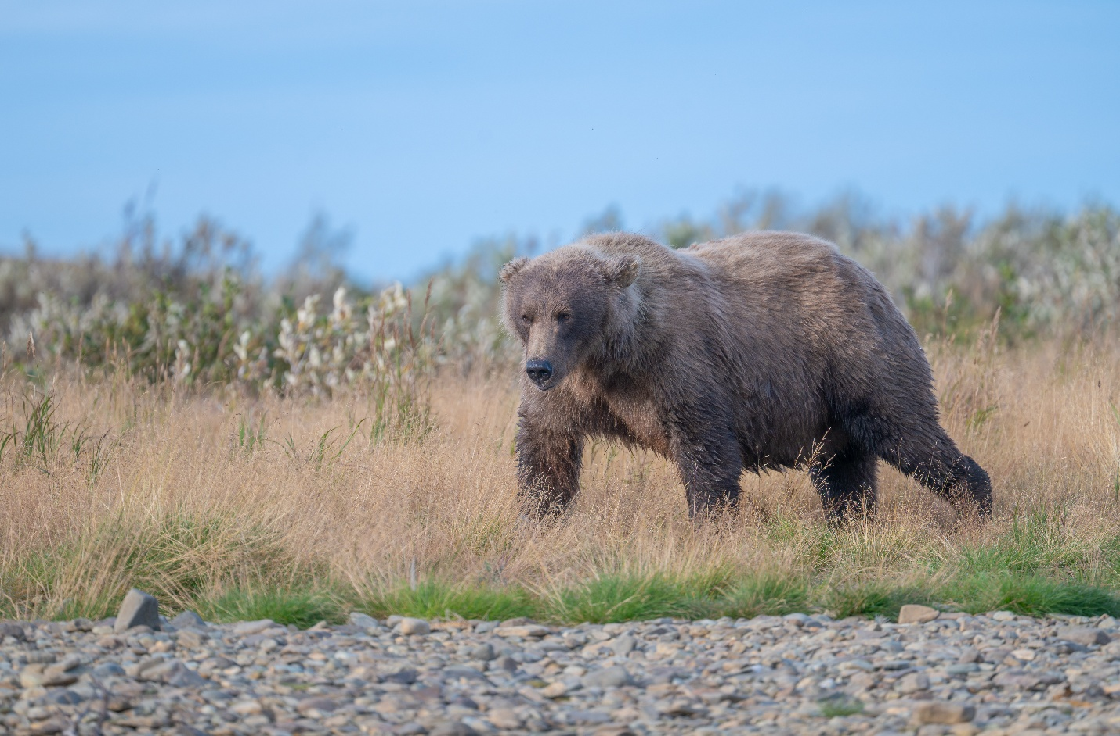

The Response from Alaska
The Alaska congressional delegation is highly engaged, though their reactions range from sharp condemnation to cautious "fact-finding." Because Alaska contains the nation’s two largest national forests (Tongass and Chugach), federal cuts have a disproportionate impact on the state's economy and tourism.

Alaska’s Delegation Responses
Senator Lisa Murkowski (R): She has been the most vocal critic, despite being a Republican. She condemned the "indiscriminate" and "unlawful" firings of federal workers, emphasizing that public servants are "not our enemies".
Defense Strategy: Her office is in "fact-finding" mode to mount a defense of Alaska-based staff during the 2026 appropriations process.
Specific Concerns: She highlighted the danger of losing staff who manage 14,000 daily cruise tourists at Mendenhall Glacier and fire support personnel.
Budget Vote: In April 2026, she broke ranks with her party to vote against a budget resolution, citing concerns over how it removed critical agencies from annual congressional oversight.
Representative Mary Peltola (D): Peltola has consistently opposed the cuts, focusing on the "talent drain" in rural gateway communities. She has joined broader Democratic efforts to demand a reversal of layoffs that she argues "endanger the economic prosperity" of Alaskans.
Senator Dan Sullivan (R): While generally supportive of reducing federal "bloat," Sullivan has expressed concern regarding the lack of clarity on how the restructuring affects resource development (timber and mining) and land management in the state.

Local Impact on Alaska
Area Affected - Recorded Impact (2025–2026)
Workforce Loss - Workforce dropped from ~700 to 467 (a ~33% decline).
Regional Office - The Alaska Regional Office in Juneau is being downsized to a "reduced state office".
Anchorage Facility - A key Forest Service facility in Anchorage was slated for closure in April 2026.
Visitor Safety, Reports indicate a lack of "bear safety" staff and trail guides for the million-plus cruise ship visitors expected this summer.

State-Level Pushback
The leaders of the Alaska State Legislature (Senate President Gary Stevens and Speaker Bryce Edgmon) sent a formal letter to the federal delegation in 2025, calling the cuts "reckless" and a direct threat to the state's social well-being. They argue that the state cannot financially fill the gaps left by the withdrawal of federal management services.
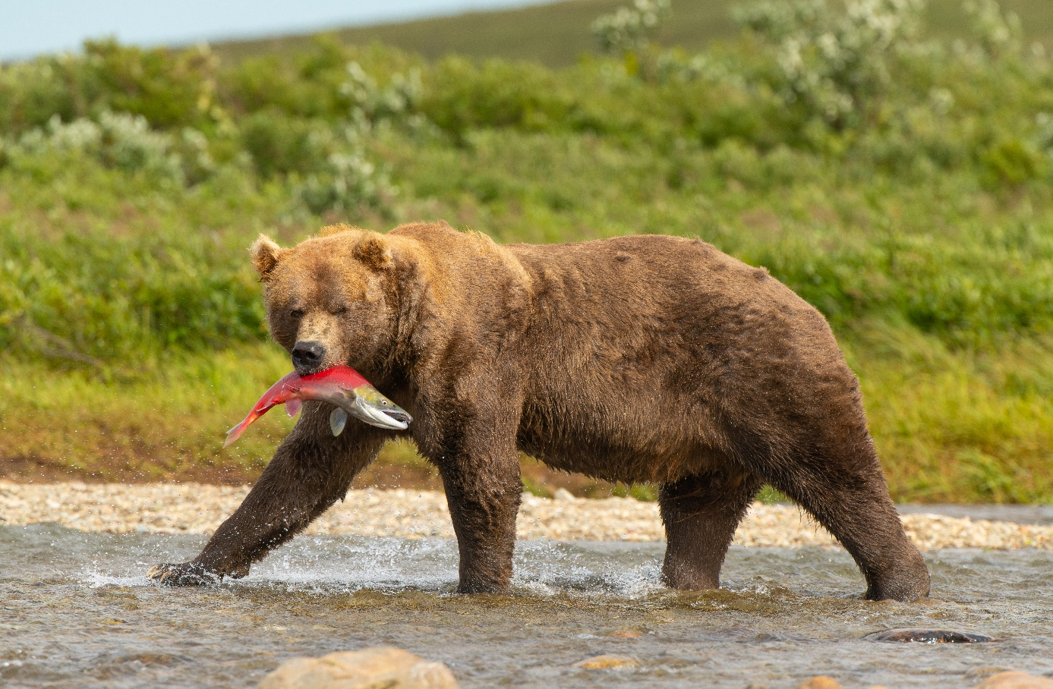

Impact on Tourism Numbers
National park visitation declined by nearly 9 million visitors in 2025. While 2024 was a record-breaking year, total recreation visits fell to 323 million in 2025, a decrease of approximately 2.7% to 3%.
The decline is attributed to a combination of policy changes, labor disputes, and natural events:
Declining Services: Staffing losses (estimated at 13% of the workforce since January 2025) and budget pressures have led to fewer open facilities, unmaintained trails, and reduced educational programming.
Visitor Hesitancy: Tourism operators report that potential visitors are "pausing" or delaying trips due to uncertainty over whether specific parks or services will be open.
Specific Regional Hits: Urban sites saw the steepest percentage declines; for example, Martin Luther King, Jr. National Historical Park saw visits drop by 44.2%.
Shutdown Disruptions: A 43-day partial government shutdown in late 2025 significantly disrupted peak fall travel, though many parks remained technically open with limited staffing.
International Boycotts: High entry fees for foreign visitors and organized boycotts from Canadian travelers have further dampened international tourism numbers.

Social Media Sentiment
Social media sentiment regarding the 2025–2026 restructuring is overwhelmingly negative, though a small but vocal group supports the changes as necessary efficiency measures.
Public Outcry: A USDA analysis of 47,000 public comments found that 82% were negative, while only 5% expressed a positive tone.
Negative Consensus: Most viral content focuses on "reckless dismantlement," loss of wildfire safety, and the "traumatizing" of long-term federal employees.
Supportive Minority: Proponents on social media platforms, including some ranching and timber groups, argue that the reorganization reduces "bureaucratic paralysis" and "regulatory overreach".

Top 5 Social Media Groups & Campaigns
The most influential online groups driving these conversations include:
SaveUSFS.org (altNPS): An influential "rogue" advocacy presence that has mobilized over 70 outdoor brands and thousands of followers to pressure the administration.
National Parks Conservation Association (NPCA): Using its massive following to share "action alerts" and data on how the 2026 budget could shutter 75% of the park system.
Outdoor Alliance: Leads digital campaigns to help recreationists submit public comments and advocate for trail restoration and wildfire mitigation.
Sierra Club: Focuses on Instagram and TikTok to highlight the connection between staffing cuts and the climate resilience of public lands.
Perfect Union: A pro-labor nonprofit that launched a multimillion-dollar campaign, including 300 billboards and viral video content, to protest the "DOGE" layoffs.

Washington-based research facilities slated for closure
The U.S. Forest Service has targeted two primary research laboratories in Washington state for closure as part of its nationwide restructuring plan announced in April 2026.

Washington Research Facilities Slated for Closure
- Wenatchee Forestry Sciences Laboratory
- Address: 1133 N. Western Ave, Wenatchee, WA 98801.
- Focus: Hydrology, soil science, climate, and natural resource management east of the Cascades.
- Impact: Home to approximately eight scientists and support staff; serves as a critical base for field crews in the Okanogan-Wenatchee and Mount Baker-Snoqualmie National Forests.
- Pacific Wildland Fire Sciences Laboratory (Seattle)
  - Location: Seattle, WA (Partnered with the University of Washington).
  - Focus: Applied wildfire science, including fire behavior west of the Cascades and climate-resilient land management.
  - Impact: Supports roughly 21 staff members plus graduate students and international fellows.

Facilities Remaining Open
The restructuring plan specifically spares certain locations to maintain a consolidated state-level presence:
- Olympia State Office: This facility is slated to remain open to house the newly established state-level leadership.
- Experimental Forests: The agency states it is not shutting down experimental forests or ranges (such as those in the Entiat or Wind River areas), though specific "under-utilized" buildings on those lands may be closed.

USFS Reorganization Context
These closures are part of a broader mandate to shut down 57 of 77 research labs nationwide.
- Consolidation: Research management is being centralized to a single organization in Fort Collins, Colorado.
- Official Justification: The USDA claims closures refer to "individual buildings" and that staff will be moved to fewer, more efficient facilities to reduce a $3 billion maintenance backlog.
- Scientific Concern: Local experts argue that losing these specific labs removes vital regional expertise needed for the distinct forest types on either side of the Cascade Mountains

What This Means — And Why It Matters Now
- Stay informed – Rapid changes to the U.S. Forest Service and National Parks are already impacting access, safety, and conservation efforts.
- Plan ahead – Expect reduced services, limited staffing, and potential closures when visiting public lands in 2026 and beyond.
- Make your voice heard – Public comments, outreach campaigns, and advocacy efforts are actively shaping the future of these lands.
- Support organizations on the front lines – Conservation groups, outdoor brands, and local advocates are working to preserve funding, staffing, and protections.
- Protect what’s at stake – America’s forests, parks, and public lands depend on awareness and engagement to ensure they remain accessible, safe, and sustainably managed for future generations.

